4.41: a)
b) Differentiating, the velocity as a function of time is
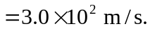

c) The acceleration as a function of time is

so (i) at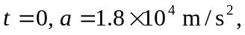 and (ii) 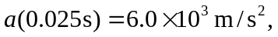 and the forces are (i) 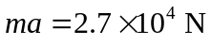and (ii) 